# Swift Update Log

*Creator/Maintainer: Kevin Styers (*[*kstyers@battelleecology.org*](mailto:kstyers@battelleecology.org)*)*

This log will detail any minor/major changes to the Swift application as the continuous development proceeds, keeping occasional and power users aware of any changes that may impact their work. If you have a question or concern about an update, **PLEASE** email or IM the maintainer. With your help we can continue to serve up helpful data for all NEON teams.

**0.9.4** – 2021-05-04

* **QFQM:** Temporarily disabled as we implement a better version…
* **New Feature: *TIS Maintenance***
* This addition will allow for users to quickly query their maintenance data from Fulcrum from the same location they can access other troubleshooting data. More coming in future releases!

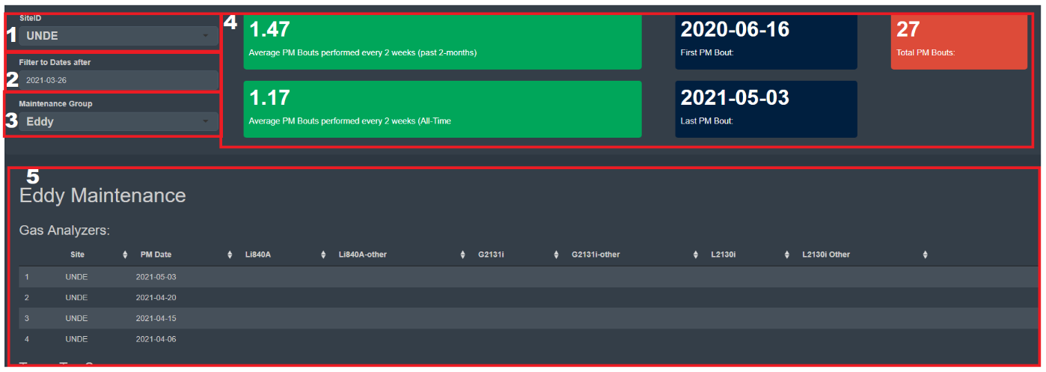

* How to use this new tab:

1. Select the TIS site for which you’d like to observe maintenance data
2. Select the data after which you’d like data from. Ie I want PM data after 2021-03-26
3. Select the group of data you’d like to inspect (Tower, Soil, Eddy, DFIR, Comments)
4. Value boxes that show useful info such as the 2-week PM bout frequency (ideally 1)
5. The actual maintenance data collected in the field via the (TIS) Maintenance [PROD] Fulcrum application

**0.9.3** – 2021-03-04

* **Overall**: Added “popup” text modal to UI to tell users when they log in there has been updates

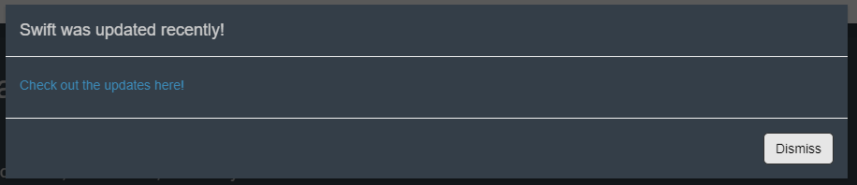

* **Eddy Co Tab**: Reduced size of “Data Collected in:” value box
* **Eddy Co Tab**: Fixed failed plotting for Li840 Co2/H2o when no valve data was found
* **Eddy Co Tab**: Added value boxes for network wide validity calculations of the core EC sensors

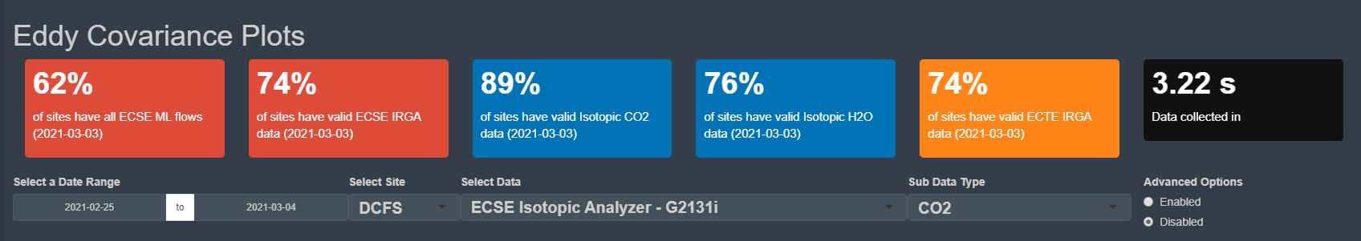

* **Gas Cylinder Tab**: Fixed bug where upon deleting the currently selected site in the “Select SiteID” input would crash the app.

**0.9.2** – *2021-03-03*

* **Home Tab**: Adding change log to home tab for users to easily access latest changes

**0.9.1** – *2021-03-03*

* **Overall**: Fixed library calls on den-prodshiny-1, aws.s3 libraries could not be installed on server
  + This update will only be applied to the shiny server stack, not the ISSOM stack

**0.9.0** – *2021-03-02*

* **Overall**: Adding padding around all tables in the app
* **Overall**: Changed all plot point colors to be more visible in dark mode
* **Overall**: Change text size, face, and color for selectInputs so that text is clearer when selecting an option.

*Before:* *After:*

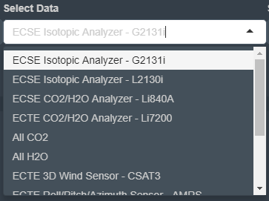 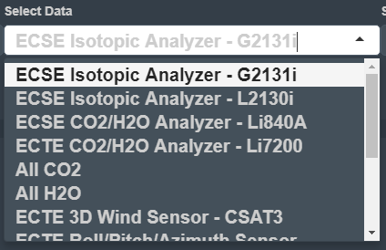

* **Eddy Co Tab**: Fixed CSAT3 plotting bugs
* **Eddy Co Tab**: Fixed “All Co2/H2o” plotting bugs
* **Eddy Co Tab**: Change names of columns, “strm_name” now is “Stream Name.”
* **Eddy Co Tab**: Changed plotting logic for all “Sample Valve” plots to be more robust/precise
* **Eddy Co Tab**: Changed “good data” threshold alphas from .2 to .4 for more visibility in dark mode